MONYETLA BURSARY PROJECT - 16 MAY 2026
THE HUMAN EAR
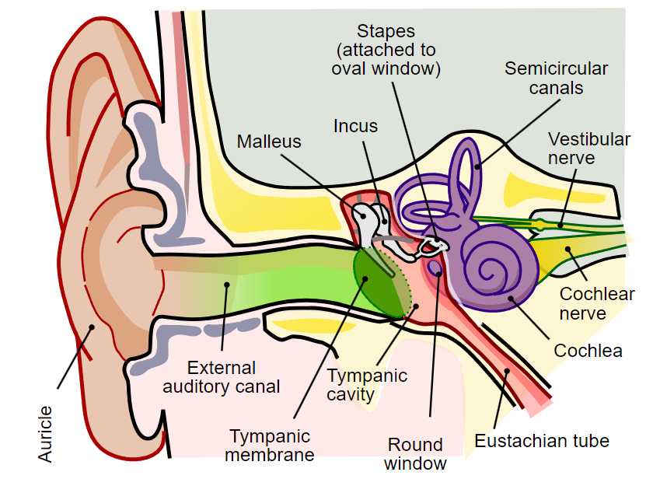
The Sense of Hearing
Sound Waves
are converted to
Vibrations
are converted to
Pressure Waves
are converted to
Impulses which are conducted to the cerebrum via the Auditory Nerve.

EXAM QUESTIONS
Easy to Score Publication
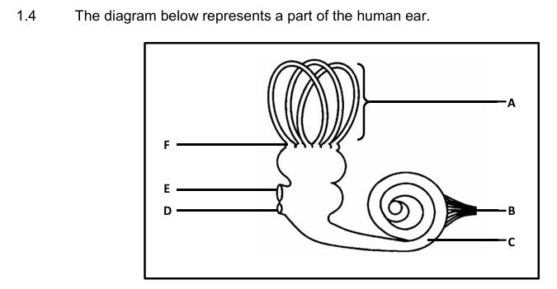
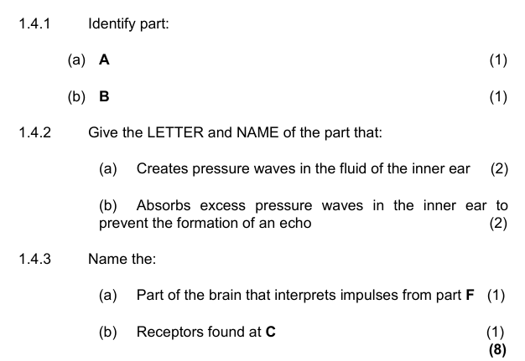

FS September 2025 P1
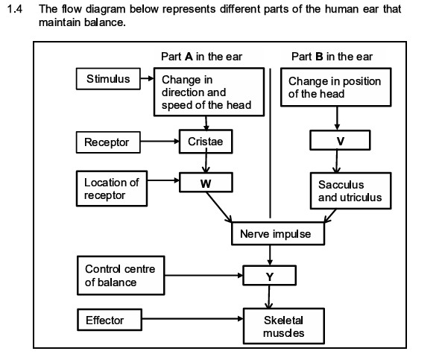
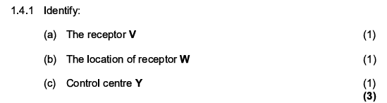____
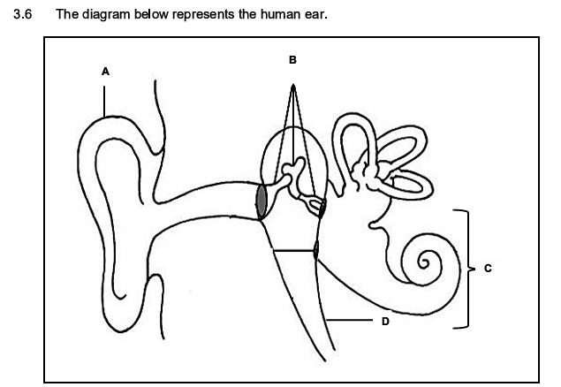
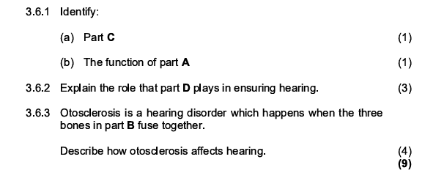
ANSWERS
Easy to Score Publication
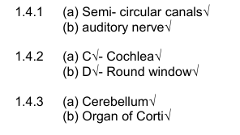
FS September 2025 P1

